##### Pilgrims of Hope: Jack Traynor FIA Reflection Point

###### This reflection point is suitable for any candidates who are wanting to receive their Bronze, Silver or Gold award level.

###### This reflection point allows the young people to focus on our Jubilee theme – Pilgrims of Hope. What does it mean to have hope? To be a pilgrim? And what makes a pilgrimage different from a holiday? Will be some of the questions answered.

###### One pilgrim who set out on a journey and found renewal and hope is Jack Traynor, he is now the 71st official miracle to have happened in Lourdes and the first person from England to be recognised. His story outlines the understanding of what it means to be pilgrim but more importantly, a pilgrim of Hope.

“For we walk by faith, not by sight.” 2 Corinthians 5:7

|  |  |  |
| --- | --- | --- |
| 0.00 | Group arrivals and settle down |  |
| 0.05 | Guess the slogan  *Each slogan has four optional answers, the young people to guess and the correct one will be highlighted on screen. PPT attached.*  *The last one being Pilgrims of Hope.*  Explanation  *Some of those slogans were trickier than others but in some way when you look at the options given you can associate it more with one company than another. The whole point of a slogan is to make sure the audience has a clear message about your company or thing. So, what does it mean to be a pilgrim of hope for us?* |  |
| 0.15 | *Introduction to the theme*  *What does it mean to have hope? What does it mean to not have hope?*  *Dictionary definition – a feeling of expectation and desire for a particular thing to happen.*  *Give the young people a minute to discuss what it might mean for them.*  *Possibly use the trip advisor reviews PPT, to give examples of how easy it is to lose hope in the world and in others.*  *What does it mean to be a pilgrim?*  *Dictionary definition – a person who journeys to a sacred place for religious reasons.*  *Optional Resource –*  *What is the Jubilee Year of Hope?* [*https://www.youtube.com/watch?v=oSWe3dsiOPo*](https://www.youtube.com/watch?v=oSWe3dsiOPo)  *Jubilee quiz worksheet – Find below.* |  |
| 0.20 | Pilgrimage Worksheet  *Young people will be challenged to match the picture with the place and then match the correct fact.*  *The worksheet is designed for young people to understand where people may go on pilgrimage and why that place might be special to go to.*  *More information on these places for the leader is attached.* |  |
| 0.35 | *What is the difference between going on holiday and going on pilgrimage?*  *Allow the young people to discuss in their groups.*  [*https://www.youtube.com/watch?v=3uZEnwY-GzI*](https://www.youtube.com/watch?v=3uZEnwY-GzI) |  |
| 0.40 | The Good News  *“For we walk by faith, not by sight.” 2 Corinthians 5:7*  What does this scripture passage mean?  *Christians should base their lives on their belief in God, even when they cannot physically see evidence or proof of His presence, essentially trusting in His promises despite any visible circumstances; it encourages relying on faith rather than solely on what they can perceive with their eyes.*  *One person who is an example of this is Jack Traynor.* |  |
| 0.42 | Jack Traynor BBC News Video  *This video was posted back in 2018 when the family wanted to make an appeal for more evidence to allow Jack Traynor to be recognised in the Catholic Church as a miracle.*  *Last year when we were in Lourdes for our annual Pilgrimage with 250 young people, Archbishop Malcom McMahon and others were called to an urgent meeting with the Lourdes authorities. It is believed that last year someone was sorting out all of the archives which are held in Lourdes regarding miraculous healings and came across a doctor’s note which confirmed that Jack Traynor was in fact fully recovered from his injuries. This was the one document that was needed for the Church and Lourdes to recognise it as a miracle.*  *This year, when we go to Lourdes he will be the 71st miracle that has happened, the first from England and believe it or not from our hometown, Liverpool.*  *Information on his story is attached below.* |  |
| 0.50 | Prayer/ Collective Worship  Bible Story – Parable of the Mustard Seed (Matthew 13:31-32) - <https://www.youtube.com/watch?v=EWN299sB5ng>  It’s the hope that something so small and possibly insignificant can become extraordinary in the eyes of God. What is it that we hope for in the world?  Possibly recreate this idea in the chapel, classroom or parish. <https://www.youtube.com/watch?v=dlcU5uHMdTM>  Journal Time  Do you ever find it difficult to be hopeful? (Is there a situation or experience you can think of?)  What or who gives you hope for the future?  Can you describe how hope makes you feel inside?  Can you think of anyone who might need hope in?  How have you already brought hope into the world?  What could you do to help other people’s hope grow?  Interactive Prayer (Play Way Maker – Leeland)  Plant a seed and watch it grow. You could use a seed from a piece of fruit, like an apple, or seeds you have in the garden. Plant it in soil, or on cotton wool. Make sure you water it a little bit each day and give it some sunlight. As you watch it grow, remember that your hope can grow like this too. If you are comfortable to do so, you may like to ask God to help you hold on to your hope, and for your hope to keep growing.  Alternatively, you can watch a seed growing here: <https://youtu.be/oDBX2gCXxYw>  Another idea is to find a branch outside and place it in your Chapel, classroom or parish. Use the leaf templates below and ask the young people to set themselves a challenge on bringing hope into the world and to decorate the leaf and make it personal to them. Hopefully, every time they enter that environment, they will remember the challenge that they have set for themselves.  You could use the examen prayer to reflect on your hopes. It has 5 steps, so you might like to count them on your fingers.  1. GIVE THANKS for something that was good today  2. ASK FOR HELP with something you have lost hope for  3. REFLECT on your day and think about the things that made you feel hopeful and the things that felt unhopeful  4.SAY SORRY for the times you gave up hope, or took away someone else’s hope  5.DECIDE how you will keep hold of hope tomorrow. |  |

**Other Notes and Ideas:**

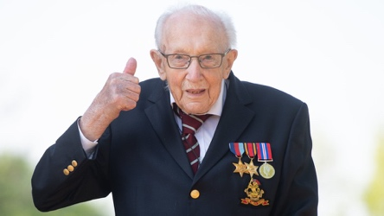Inspirational People : **Captain Tom Moore**

Show a picture of Captain Tom Moore. How did he become a beacon of hope for people in challenging times? He told the nation ‘We will get through it in the end but it might take time, but at the end of the day we shall all be okay again... the sun will shine on you

again and the clouds will go away."

Read Hebrews 11:1 ‘To have faith is to be sure of the things we hope for, to be

certain of the things we cannot see.’ It is not easy to have the type of hope Captain Tom speaks of but if we need help with hoping about anything we can ask God to strengthen us.

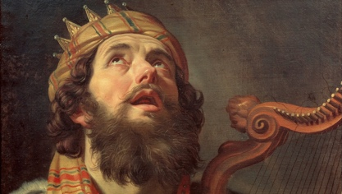**King David** had watchmen on the city walls of Jerusalem to protect it from enemies. Help young people imagine a city wall with its watchtower. How would David feel waiting at night? Perhaps he had to remind himself that the sun would come up in the end, even when it felt as though it never would. The Bible calls this sort of waiting ‘hope’. It means that you are sure that what you’re waiting for will happen in the end. Being hopeful is not about denying the challenges. It’s about knowing that you feel challenged and despite the challenge, trying to remain hopeful. Sometimes it can be helpful to remember that feelings come and go - ‘this too shall pass’.

Artwork

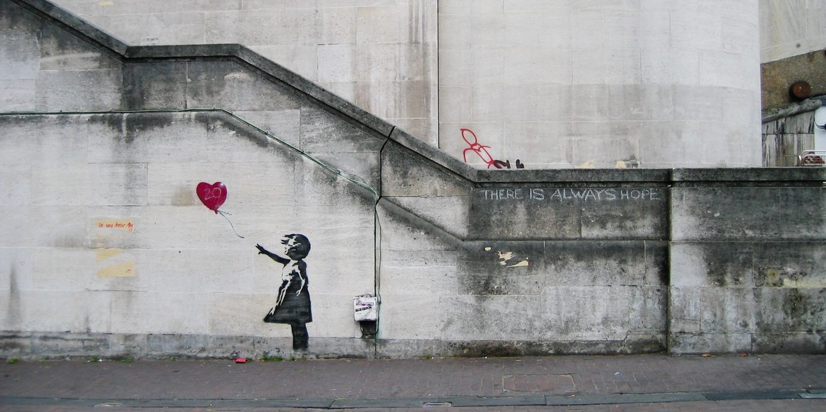

**‘Girl with Balloon’ - Banksy**

Does this artwork make you think about hope? What do you think the girl is thinking? What do you think the balloon might represent? Do you agree with the words on the wall ‘there is always hope’? If so, why?

**Other Scripture:**

**Road to Emmaus (Luke 24:13-35) *Jesus came and walked along with them*.**

In what follows, the story will be explored through three images and the acronym ‘DAOR’ (‘road’ backwards). You might wish to copy or print the three images to show the young people. The letters (and subsequent words) can be written on a whiteboard.

In this story, we meet two disciples as they are journeying from Jerusalem to the village of Emmaus. When we look back at this biblical story, there are some things that stand out:

At the start of this story, we find the disciples disappointed and disheartened (add these words to the ‘D’ on the board).

The disciples had lost hope because of what had happened in Jerusalem a few days before. Jesus had died and his body had gone missing; they were expecting things to

turn out a little bit differently… Wasn’t Jesus the promised Messiah who would overthrow

the Romans and bring peace to all? That dream seemed a little lost… As a result, the disciples were a little anxious (add this words to the ‘A’ on the board).

‘What did the future hold now? What could we now hope for?’ The disciples were so worried that they could only focus on their troubles and disappointments. They were so worried they didn’t recognise that the person, who was now walking alongside them, was Jesus.

As they travelled, Jesus asked what was troubling them. The disciples explained the events of the last few days – how Jesus had died and how there were now reports that his body had

gone missing. Jesus listened very carefully, and then started to open up new possibilities

(add ‘open’ to the ‘O’ on the board).

He explained that the messengers and prophets of old had all pointed to these things happening; do not worry, all of these things will turn out well. And, as they ate together, their eyes were opened too – they finally recognised that this person was Jesus himself! The disciples realised that they had lots of reasons to be hopeful (add ‘reason’ to the ‘R’ on the board).

Through walking with and meeting Jesus they were no longer disappointed or disheartened; they now thought that Jesus’ death and missing body had actually pointed to the greatest hope possible. They ran back to Jerusalem to tell the other disciples what they had seen and heard.

If those disciples were asked the question, ‘How can you have hope for tomorrow?’, I wonder what they would have answered? Perhaps they would have replied, ‘We have hope because Jesus is alive and joined us on our journey!’.

**Questions for journalling on the Road to Emmaus**

The story of the Road to Emmaus draws attention to three themes.

First, we meet the disciples travelling from Jerusalem to the village of Emmaus. We find them disappointed and disheartened; they had lost hope because of what had happened in Jerusalem a few days before. Jesus had died and his body had gone missing; the disciples were expecting things to turn out a little bit differently. Wasn’t Jesus the promised Messiah who would overthrow the Romans and bring peace to all? In focussing too much on their worries and concerns, they failed to notice who had joined them.

**Do we sometimes focus too much on our worries that we miss the hope and good things**

**right in front of our eyes?**

Second, the story tells of Jesus joining the disciples on their journey; he walks alongside them and listens to their fears for the future. In putting things into perspective, Jesus helps the disciples realise that there is a lot to be hopeful for. Many Christians feel that life is a bit like the ‘Road to Emmaus’ – Jesus walks with them and points to a more hopeful future.

**Who supports us on our life journeys? Who do we turn to when we our worried about the**

**future?**

Thirdly, following their encounter with Jesus, the disciples were able to reflect back on their journey. Their eyes were opened to a more hopeful future as they had discovered new things about God and themselves.

**What have you learnt about yourself, God or life over the past year which gives you hope?**

**How can you have hope for the future? Where does that hope come from?**

**Alternative song – One Way Jesus**

**More upbeat and has the lyrics ‘we walk by faith and not by sight in you’.**

**Top 10 Religious Pilgrimages and Christian Tours in Europe and the Mediterranean**

**Keytours Vacations – Kate Jarvis**

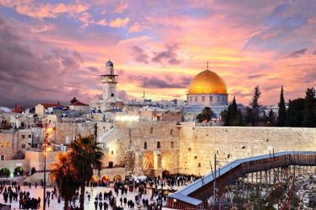**1. Jerusalem, Israel**

Journey to Jerusalem and the Holy Land and visit popular sites including The Western Wall, also referred to as the Wailing Wall, the site of the original Jewish Temple. Along your pilgrimage tour the The Temple Mount, considered the third holiest Islamic site after Mecca and Medina where two mosques are located: Al-Aqsa and Dome of the Rock. The Church of the Holy Sepulcher is a church built on the spot where some Christians believed Jesus was crucified, buried, and resurrected, now one of the most sacred places of the Christian faith.

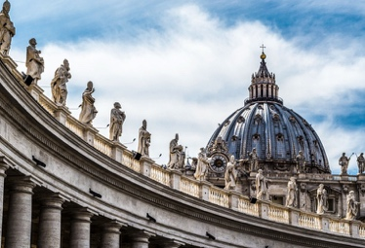**2. Rome, Italy**

Take in the beauty of this historic city with visits to the many religious and sacred sites of Rome. Begin with Saint Peter's Basilica, the great cathedral of the Vatican and one of the seven ancient pilgrimage churches of Rome. Continue on to the Papal Basilica of Saint Paul outside the Walls, one of Rome's four major basilicas. Another site to visit is the Abbey of the Three Fountains, the site of the martyrdom of Saint Paul.

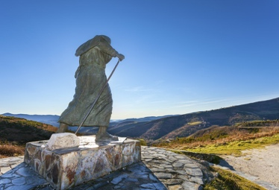**3. Way of Saint James, Spain**

Follow the path to spiritual growth on The Way of Saint James, aka the Camino de Santiago. There are dozens of pilgrimage routes to choose from on the way to Santiago de Compostela. Visit the many cathedrals on the way including the Santa María de León Cathedral, a masterpiece of the Gothic style and the Cathedral museum which houses a large collection of sacred art. Other notable religious sites include: the Cathedral of Astorga, the Episcopal Palace of Astorga (designed by Antoni Gaudí), the Cruz de Ferro (a cross on the Camino de Santiago, located between Foncebadón and Manjarín), and the Royal Monastery of San Xulián de Samos.

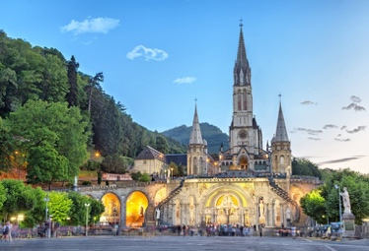**4. Lourdes, France**

A popular destination for pilgrims, the Grotto at Massabielle & the surrounding Sanctuary of Our Lady of Lourdes is a site where an apparition of the Immaculate Conception is claimed to have been seen and where pilgrims are reputed to be healed by the Lourdes water. Lourdes is also the site of a number of churches including the Crypt, the Upper Basilica, the Rosary Basilica, the Church of Saint Bernadette, and Saint Joseph's Chapel.

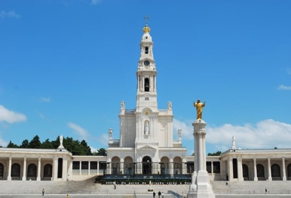**5. Fátima, Portugal**

Fátima is home to the Sanctuary of Fátima, a Catholic pilgrimage site and a group of Catholic religious buildings. The Chapel of the Apparitions marks the spot of famous apparitions of the Blessed Virgin Mary. Other sacred sites include the Basilica of Our Lady of the Rosary, the church of Igreja da Santíssima Trindade and the Museu de Arte Sacra e Etnologia which exhibits religious artifacts.

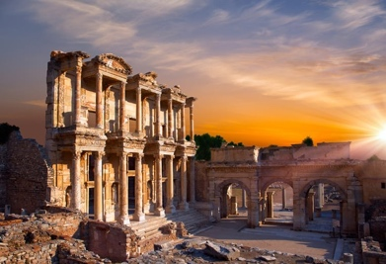**6. Seven Churches of the Revelation, Turkey**

The Seven Churches of Revelation in Turkey are also known as the churches of Asia which were cited in the Book of Revelation: Ephesus, Smyrna, Pergamum, Thyatira, Sardis, Philadelphia, and Laodicea. Ephesus is one of the top visited touristic attractions in Turkey and home to the Library of Celsus as well as many other monumental buildings. Smyrna is the site of an Ancient Greek city known today known as Izmir, Turkey where visitors can explore the Columns of the Western Stoa. In Pergamum visitors come to see the Hellenistic theatre, acropolis, and Roman baths complex.

**7. Canterbury, England**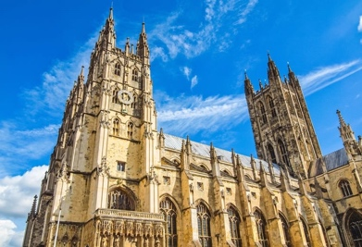

Follow the "Pilgrim's Way" taken by pilgrims from Winchester in Hampshire England to the shrine of Thomas Becket at Canterbury in Kent. Although much of the traditional route is now park of a modern road network, the North Downs Way National Trail parallels the old Pilgrim's Way. The Canterbury Cathedral, one of the oldest and most famous Christian structures in England, is both a holy place and part of a World Heritage Site.

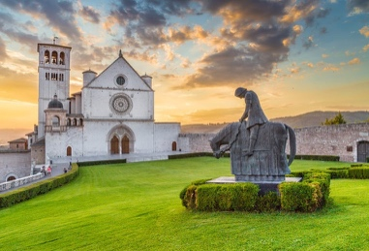**8. Assisi, Italy**

Assisi is the home town and burial place of Saint Francis and an important Franciscan pilgrimage destination. One of the highlights of Assisi is the Basilica of Saint Francis of Assisi, a UNESCO World Heritage Site, comprised of two churches known as the Upper and Lower church including a crypt.

**9. Altötting, Germany**

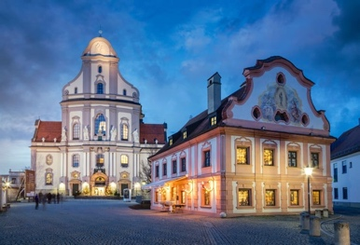Altötting, in the heart of Bavaria, is called the "Lourdes of Germany" as many pilgrims journey to the Shrine of the Black Madonna in search of healing. The Chapel of Grace is the national shrine dedicated to the Virgin Mary, Another notable site is the Basilica of St. Ann, the largest church built in Germany in the twentieth century.

**10. San Giovanni Rotondo, Italy**

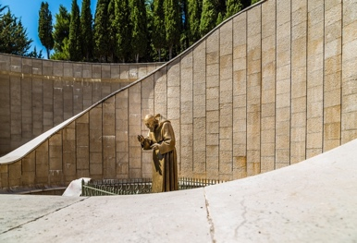An important site in San Giovanni Rotondo, Italy is the Church of Our Lady of Grace (Santa Maria delle Grazie) and the Shrine of Padre Pio, the second most visited shrine in the world, centring on the tomb of Saint Padre Pio of Pietrelcina. Saint Padre Pio is known to have supernatural abilities including miraculous healings, the readings of souls, and personal visits from Jesus and Mary.

# I Met a Miracle

## The story of Jack Traynor, by the Reverend Patrick O'Connor, missionary of St Columban.

On Friday morning, September 10th, 1937, I came face to face with a miracle. The meeting place was a bustling railway station in France. There was no mistaking the miracle, as with the weight and strength of sixteen stone of burly humanity it helped me to fight my way on to a crowded train.  
  
The name of the miracle was John Traynor. I first beheld him as I came along the platform with my suitcase and saw him waiting to board the coach in which I hoped to ride. A powerfully built man, about five feet ten in height, with a strong, wholesome, ruddy face, dressed in a rather rumpled grey suit, carrying his travelling bag, he stood out from the surrounding crowd. Two of his little boys were with him, and eight or ten Irish and English pilgrims on their way home from Lourdes.  
  
Now John Traynor was a miracle because, by all the laws of nature, he should not have been standing there, hefty and healthy. He should have been, if alive at all, paralysed, epileptic, a mass of sores, shrunken, with a shrivelled, useless right arm and a gaping hole in his skull. That is what he had been. That is the way medical science had certified that he must remain. Only a miracle could cure him. ... A miracle did.  
  
I rode with him for about ten hours in the train that day, and when I said good-bye to him in Paris that evening, it was with the certainty that I could never forget him. He was a delightful character, this big Liverpool Irishman, with his manly faith and piety, lacking all trace of exaggeration in one direction or the other; unaffected and unassuming, yet obviously a fearless militant Catholic; with only a primary education but with a clear mind enriched by the faith and preserved by a great honesty of life. Not for his personality, however, am I bound to remember him but for his story, which he told me on our long journey that day. He told it simply, soberly, exactly,a narrative that it was a grace to hear and is a duty to recall.

VERIFIED- Afterwards I wrote it down and sent my version back to him for checking. Painstakingly, with the aid of Mr John Murray, the old schoolmaster who had taught him as a boy in St Patrick's School, he went over the manuscript, correcting, filling in gaps, adding details. I had the files of the Liverpool newspapers searched to find the corroborative evidence of their reports. I obtained copies of newspaper photographs taken at the time of the miracle. I read the official report signed by six doctors, four English, one French and one Belgian, and issued by the Medical Bureau in Lourdes when more than three years had elapsed to allow for careful examination of all the evidence and to establish the permanence of the cure.  
  
And now, here is the story of John Traynor.  
  
John Traynor was born and reared in Liverpool. His Irish mother died when he was still quite young, but her faith, her devotion to Mass and Holy Communion and her trust in the Blessed Mother stayed with him as a memory and a fruitful example. "She was a daily communicant when few people were," he told me.

IN THE FIRST WORLD WAR - The first world war broke out in 1914, and Jack Traynor was mobilized with the Royal Naval Reserve, to which he belonged. He was in the naval brigade that took part in the unsuccessful Antwerp expedition of October, 1914, and was in the last battalion to retreat. He was carrying one of his officers to safety, when he was hit on the head by shrapnel. He did not regain consciousness until five weeks later, when he woke up after an operation in a marine hospital in England. He recovered rapidly and went back into service. In 1915, lent to the 1st Dublin Fusiliers, as physical instructor, he was a member of the expeditionary force sent to Egypt and the Dardanelles.  
  
On April 25th, 1915, he took part in the landing from the steamship 'River Clyde' at Gallipoli. He was in charge of the first boat to leave the ship and was one of the few to reach the shore that day. From their positions in the steep banks above the beach the Turks raked the 'Clyde' and the boats with deadly gunfire. The casualties were so heavy that the operation was suspended until nightfall. Meanwhile all the officers in the landing parties had been killed, and Traynor found himself in charge of about 100 men, who took cover in a shallow trench. A Catholic chaplain, Father Finn, was killed in the second boat, from which he fell. Traynor dragged him from under the barbed wire and later he and his comrades buried him on shore.  
  
After dusk more officers and men landed, and the small force began to fight its way, with severe losses, up to the sand hills. For days the bitter fighting continued. Traynor took part, without injury, until May 8th, when he was hit by machine-gun fire during a bayonet charge.  
  
He seems to have been literally sprayed with bullets. He was wounded in the head and chest, while a bullet tore through the inner side of his upper right arm and lodged under the collarbone.  
  
Medical corps men brought him back, dazed and suffering, to the beach, and he was shipped to the base hospital at Alexandria, Egypt. Now began his long years as an invalid and as the patient of unsuccessful operations. A well-known English surgeon, Sir Frederick Treves, operated on him in Alexandria, in an attempt to sew together the severed nerves in the upper arm, which the bullet wound had left paralysed and useless. The attempt failed, and so did another, made by another surgeon, on the hospital ship that brought Traynor from Alexandria to England. In September, 1915, in the Haslar naval hospital, England, a third operation was performed with the same object - and the same result.  
  
While on the hospital ship Traynor suffered his first epileptic attack. These attacks became frequent.

INCURABLE - The surgeon-general of the navy now advised amputation of the paralysed arm, as there seemed to be no hope of ever joining the torn and shrunken nerves. Traynor would not consent. In November, 1916, another doctor tried to suture the nerves, bringing the number of unsuccessful operations up to four. By this time Traynor had been discharged from the service, first on 80 per cent pension, then on 100 per cent as being permanently and completely disabled. He had to spend months in various hospitals as an epileptic patient. In April, 1920, a doctor realized that the epilepsy was probably the result of the head wounds, and operated on the skull. Whether bits of shrapnel were found and removed is not known, but we do know that the operation left Traynor with an open hole about an inch wide in his skull. Through this opening the pulsations of the brain could be observed. A silver plate was inserted to shield the brain. The epileptic condition was no better after the operation. The fits were as frequent as three a day. Both legs were partly paralysed, and nearly every organ in Traynor's body was impaired.  
  
An ambulance brought him back to Liverpool, where he lived with his wife and children in a house in Grafton Street. "Were very poor," he told me. The Ministry of Pensions supplied him with a wheel-chair; in this he would sit for hours outside the house. He had to be lifted from his bed into the chair and back again.  
  
The year 1923 - the eighth after he became a casualty in Gallipoli - found him leading this helpless existence. I have counted the names of ten doctors through whose hands he had passed up to then. The result of all their efforts and examinations was to prove that he was completely and incurably incapacitated. Unable to stand or walk, subject to frequent epileptic fits, with three open wounds, one of them in his head, without the power of feeling or movement in his torn and shrivelled right arm, he was indeed a human wreck. Somebody arranged to have him admitted to the Mossley Hill Hospital for Incurables on July 24th, 1923. But by that date Jack Traynor was to be in Lourdes.